# Homework M4: Storage and Persistence

Main goal is to build further on what was demonstrated during the practice

For the successful completion of the tasks, you will need a simple (two or three node) cluster as the one used during the practice

## Tasks *

Try to solve the following set of tasks:

1. Configuration maps and secrets
   1. Create a **ConfigMap** resource **hwcm** that:
      1. has two key-value pairs (**k8sver** and **k8sos**) initialized as literals that hold your **Kubernetes version** and the name of the **OS** where **Kubernetes** is running
      2. has two more key-value pairs (**main.conf** and **port.conf**) initialized from files. The first one (**main.conf**) should contain:

**# main.conf**

**name=homework**

**path=/tmp**

**certs=/secret**

And the second one (**port.conf**):

**8080**

* 1. Create a **Secret** resource **hwsec** that:
     1. Has two data entries – **main.key** and **main.crt** created from files
     2. The content for the above two generate by using the **openssl** utility. For example:

**openssl genrsa -out main.key 4096**

**openssl req -new -x509 -key main.key -out main.crt -days 365 -subj /CN=www.hw.lab**

* 1. Mount the above resources to a pod created from the **shekeriev/k8s-environ** image (used during the practice) by
     1. **k8sver** and **k8sos** should be mounted as environment variables with prefix **HW_**
     2. **main.conf** should be mounted as a volume to the **/config** folder inside the container
     3. **port.conf** should be mounted as an environment variable **HW_PORT**
     4. **main.key** and **main.crt** should be mounted as a volume to the **/secret** folder inside the container

1. Create and run a set of manifest files to spin the following application:

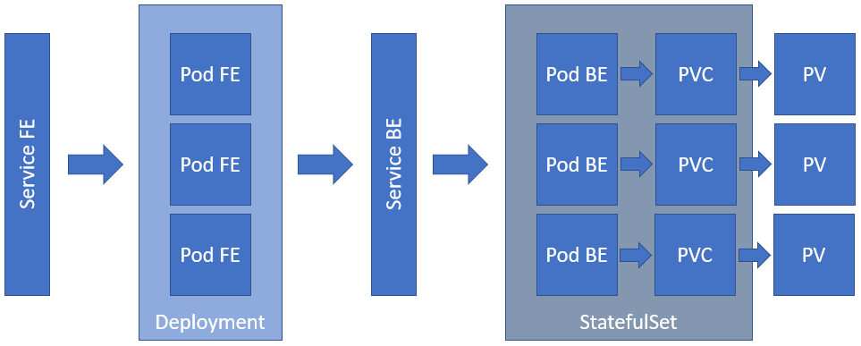

Please note that:

* Service FE should be of type **NodePort**
* **Pod FE** should use **shekeriev/k8s-facts-fe** image and should be initialized with two environment variables – **FACTS_SERVER** equal to the **name** of the **Service BE** and **FACTS_PORT** equal to the **port** of **Service BE**
* **Pod FE** listens on port **5000/tcp**
* **Service BE** should be of type **ClusterIP** *(please note, that this is not the headless service but the "public" one)*
* **Pod BE** should use **shekeriev/k8s-facts** image and expects a volume to be mounted at **/data** folder
* **Pod BE** listens on port **5000/tcp**
* For the **PVs** and **PVCs** use **NFS** and storage capacity of **2Gi**
* Both the **Deployment** and the **StatefulSet** should spin three replicas

*As usual, you are not obliged to complete all the tasks but try to tackle as many as possible*

## Proof

Prepare a document that show what you accomplished and how you did it. It can include (not limited to):

1. The commands you used to achieve the above tasks
2. A few pictures showing intermediary steps or results
3. Any configuration files and/or manifests